U.S. SENATE YOUTH PROGRAM
NEW MEXICO STUDENT APPLICATION FORM
2021-2022

Student’s Name: ________________________________________________________
First Middle Last

Home Address: _________________________________________________________
Street City Zip

Student’s Email: ____________________Student’s Cell Phone: ________________

Grade:_____________ Gender: M F

Name of High School:_____________________ School Phone: ___________________

High School Mailing Address: _____________________________________________

High School Principal: _____________________ E-mail Address: ______________

High School Counselor: ____________________ E-mail Address: ______________

2021-2022 Student Elected Position: _______________________________________

Future plans (college): ____________________________________________________

Future plans (politics): ___________________________________________________

Applicant’s Signature:____________________________________________________

Faculty Sponsor’s/Advisor’s Signature:______________________________________

Parent/Guardian Signature: ___________________Cell Phone: ________________

Printed Name of Parent or Guardian _______________________________________

Parent/Guardian Email address:__________________________________________

Parent/Guardian a resident of New Mexico? Yes No (Circle One)

PLEASE PRINT OR TYPE.
Deadline for submission of application is 4pm on October 15, 2021.
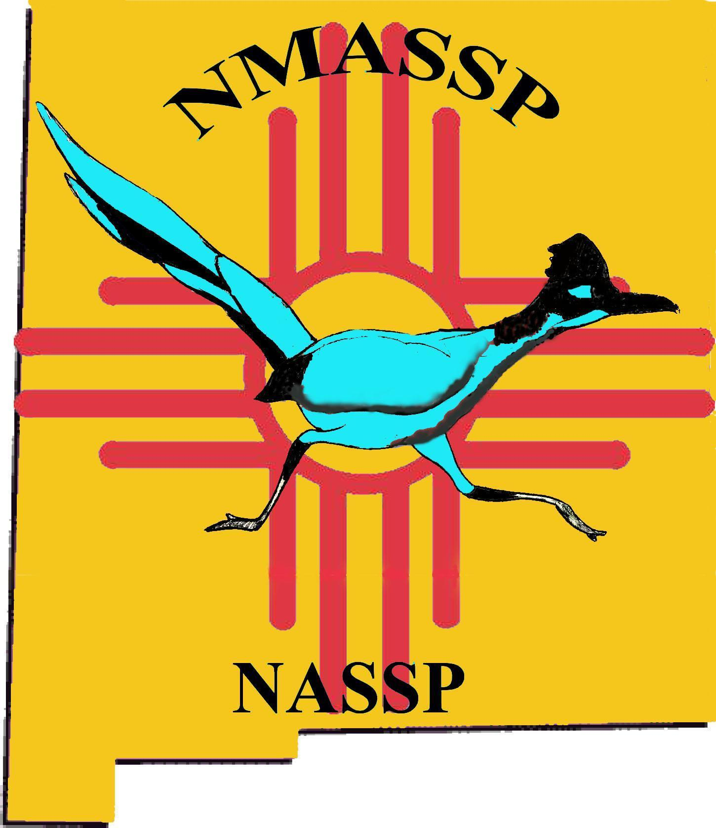

NEW MEXICO ASSOCIATION OF SECONDARY SCHOOL PRINCIPALS
An affiliate of National Association of Secondary School Principals Funded by the William Randolph Hearst Foundation

